Friday 13th October 2017

Primrose Hill Barn, Arlescote OX17 1DQ
Pre-dinner drinks and fabulous 3 course meal
7.30 pm Followed by...
“Archaeology and the Black Death: Finding Global History in your garden”
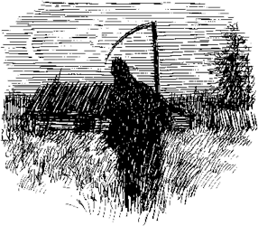
an after dinner talk by
Professor Carenza Lewis
Tickets £40 per person
Available from: Sue Baxter 01295 691011
baxtersue@btconnect.com
This is a fundraising event to support professional analysis of finds associated with the community archaeological investigations by
Warmington Heritage Group at
The National Herb Centre.

