Patron: His Royal Highness The Duke of Gloucester

Newcomen Midlands Public Lectures
In conjunction with Thinktank: Birmingham Science Museum

Wednesday 1st November 2017 - 7pm

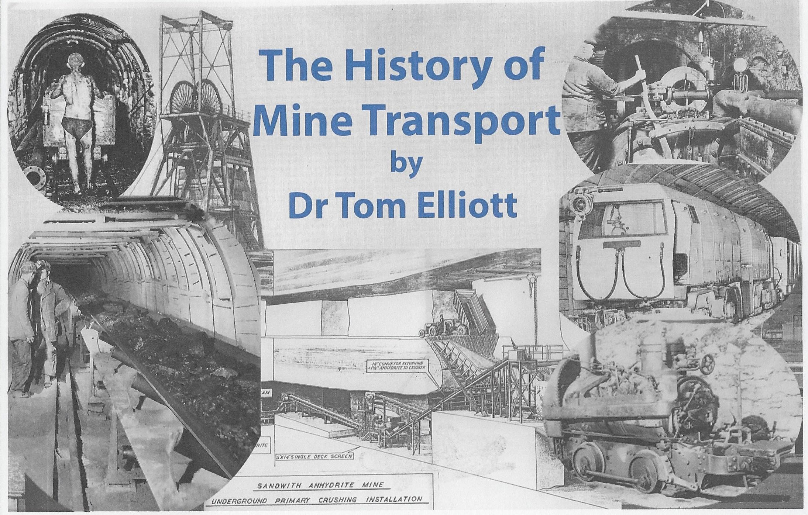

From Muscle Power to High Powered Conveyors & More

The Lecture Theatre, Level Two,
Thinktank: Birmingham Science Museum,
Millennium Point, Birmingham B4 7XG [SAT NAV B4 7AP]

EVERYONE IS WELCOME

DOORS OPEN 6.30pm ADMISSION FREE

