Warwickshire

Local History Society
W: www.warwickshirehistory.org.uk
Neville Usher, 6, The Fold, Payton Street, Stratford upon Avon, CV37 6NJ Tel: 01789 205043
Christmas at British Motor Museum
Banbury Road, Gaydon, Warwickshire, CV35 0BJ
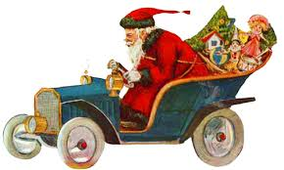
(One mile from J12 of the M40)
For our Christmas festivities this year, we have arranged something completely different. A talk by Stephen Laing on ‘Women and motor cars - from the early days through to the era of the Mini’, Christmas tea and a browse around the world’s largest collection of the British cars with some 300 classic cars.
At 2.30pm the proceedings begin, with a talk by the curator of the museum, Stephen Laing on ‘Women and motor cars - from the early days through to the era of the Mini’. After this we will enjoy a very splendid Christmas tea.
But, why not enjoy the whole day at the museum? The museum opens its doors at 10 a.m. and as members of WLHS the admission charge (which everyone has to pay anyway) will be at a reduced rate of £9. The café also opens at 10 a.m, with lunch available in their first class dining room from 11:30am.
TO BOOK: complete and send the form below and a cheque payable to 'Warwickshire Local History Society' to: Neville Usher, 6, The Fold, Payton St., Stratford -upon-Avon, CV 37 6NJ (Tel. 01789 205043).
Saturday 1st December 2018 CLOSING DATE - 15th November 2018
Name
Address
Email address
………….. WLHS members @ £13 each £………………………………………………..
….......... WLHS guests @ £16 each £………………………………………………..
Total payment to Warwickshire Local History Society £………………………………………………..
(an additional £9 will be due per person at the museum on the day)

