Warwickshire

Local History Society
W: www.warwickshirehistory.org.uk
Neville Usher, 6, The Fold, Payton Street, Stratford upon Avon, CV37 6NJ Tel: 01789 205043
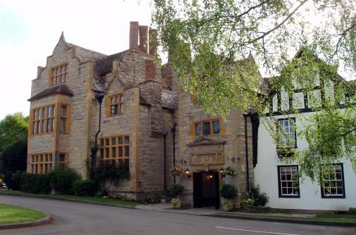
CHRISTMAS SOCIAL at SALFORD HALL, ABBOTS SALFORD, nr BIDFORD
Saturday, November 25th 2017 at 2pm
Our 2017 Christmas event (and I have been told many times that previous events have been too close to Christmas when we are busy, so we are early this year) is to a fascinating Grade I listed historic house, now the Salford Hall Hotel (WR11 8UT, Tel. 01386 871300), on the Salford Priors to Evesham road.

The Hall is the very first entry in Pickford/Pevsner's Buildings of Warwickshire. Parts of the original C15th monastic house and gatehouse remain but this is substantially the house rebuilt and enlarged around 1602 for members of the Catholic Stanford family. Stanford connections were retained into the C19th when the Hall became a Benedictine nunnery, its Catholic chapel remaining until 1948 when the house was sold and suffered serious decay before restoration in the 1980s.
At 2pm Dr Nat Alcock will lead a tour round the exterior and interior of this interesting and complex house (N.B. 3 floors and no lifts) which includes an ingenious priest's-hole and a wall-painting. At 3pm we will have an enactment by 'Guarderobe-The Past in Practice' related to the Catholic history of the house, and a seasonal tea will be served at 4pm.
Lunches at 'The Frog' at Bidford (B50 4BG - 01789 772369) and 'The Fish' at Wixford (B49 6DA - #01789 778593) have been enjoyed by WLHS members recently.
TO BOOK: complete and send the form below and a cheque payable to 'Warwickshire Local History Society' to: Neville Usher, 6, The Fold, Payton St., Stratford -upon-Avon, CV 37 6NJ (Tel. 01789 205043).
Saturday 25th November 2017 CLOSING DATE 11th November, 2017
Name …………………………………………………………………………………………………………………………………………………………

Address ……………………………………………………………………………………………………………………………………………………..

E mail address …………………………………………………………………………………………………………………………………………..

…… WLHS members @ £15 each £………………………………………………..
…... WLHS guests @ £17 each £………………………………………………
Total payment to Warwickshire Local History Society £……………………………………………..

