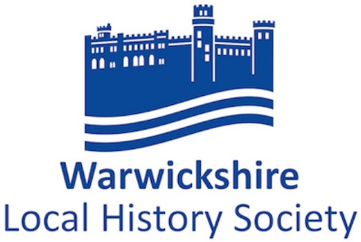e

President Elizabeth, Lady Hamilton Vice-President Mr Peter Gregory-Hood
Chairman Dr John Wilmot Vice-Chairman Dr R Bearman
Hon. Secretary Dr Ruth Barbour Hon. Editor Dr A W Watkins
Treasurer Mr Neville Usher Programme Secretary (Outings) Mrs R Fisher
Programme Secretary (Lectures) Mr J Ranahan

FIFTY FIFTH ANNUAL GENERAL MEETING
Tuesday 20th April 2021, 7.15 pm online via Zoom
AGENDA
- Apologies for absence.
- Chairman's introductory remarks.
- Minutes of AGM 17 March 2020.
- Matters Arising.
- To receive the Annual Report and Accounts for 2020.
- To elect officers for the forthcoming year.
The President, Elizabeth, Lady Hamilton and Vice-President, Peter Gregory-Hood remain in office.
The following are happy to continue in post:
Chairman: Dr John Wilmot. Vice-Chairman: Dr Bob Bearman.
Secretary: Dr Ruth Barbour. Treasurer: Neville Usher.
Hon Editor: Dr Andrew Watkins. Membership Secretary: Lesley Caine.
Programme Secretaries: Rowan Fisher (Visits) and Jim Ranahan (Lectures).

- To elect an Executive Committee for the forthcoming year – the following are happy to continue as members:
Dr Nat Alcock Dr. Christine Hodgetts
Dr John Bland David Paterson
Dr Maureen Harris Christine Woodland
Co-opted member: Miss Mairi MacDonald (Editor of ‘The Bulletin’)
Two long-serving committee members: Jackie Bland and Monica Ory have indicated they do not wish to stand for re-election. Therefore, two vacancies exist on the Committee.
Nominations for officers and members of the Executive Committee, with the agreement of the person being nominated, must be sent to info@warwickshirehistory.org.uk by Tuesday 13th April 2021.
8) AGM 2020 This was due to be held on 17/3/2020, but was cancelled due to the COVID-19 pandemic, a national lockdown being initiated shortly afterwards.
Following consultation with the Charity Commission the AGM papers were posted to all members and comments requested on the Annual Report and Financial Report and the proposed amendment to the Constitution. No comments were received.
Therefore, the Annual Report and Financial Report for 2019 were considered accepted
Likewise, no comments / opposition was received concerning the proposed alteration to Rule 5a.
This will now read:
‘(a) A General Meeting shall be held annually within five months of the end of the Financial Year at which the Society shall elect its officers, and appoint an Executive Committee.’… Applicable from 1 January 2021. [The rationale for this change is to allow more time for the production of the Financial Report]
WLHS Annual Report 2020
The society has, like everyone else, experienced an exceptional year. The COVID-19 pandemic and government restrictions have forced us to curtail our activities. Despite the constraints, the efforts of committee members and others have enabled us to continue the society’s activities in new forms.
We continued some changes instigated in 2019, such as holding meetings in Aylesford School. In January 2019 we had our first daytime meeting, an innovation adopted to save members some winter night driving. Held in January at Budbrooke Church centre, this was successful and well attended. We planned to repeat the members’ evening started in 2018, but after cancelling in April 2020 we hope to hold this in April 2021.
Publications: our programme has continued, with an interesting set of articles in Warwickshire History, under our recently elected Editor, Dr Andrew Watkins. Outreach activities were curtailed by the pandemic, as nearly all history fairs have been discontinued. However, the Society offered pre-recorded Zoom presentations at the virtual Leamington History Day in September; Jim Ranahan summarised recent topics in our Journal, and a paper by John Wilmot explored the Regency-era history of Leamington’s first hospital.
Conduct of Meetings: at the start of the pandemic restrictions, in March and April 2020, our lecture meetings were cancelled. During the summer the committee experimented with virtual meetings; in the autumn we had an introductory meeting for members, since when our talks have been given online using Zoom. In general, these arrangements have worked well.
Communication with Members: using previous permissions, we have circulated members by email almost monthly, with news of our activities and plans. This is coordinated by Lesley Caine, Membership Secretary, and feedback suggests that the messages are welcomed.
Meetings of the Society in 2020
Saturday 18 January 2020: First Daytime lecture -- Ellie Reid, local studies historian and independent researcher: Warwick Pageant & the 20th Century Pageant Movement. This was held at St Michael’s Church Centre, Church Lane, Budbrooke, Warwick. 50 members and visitors enjoyed a fascinating lecture about the 'modern' Warwickshire pageants. Using slides and souvenir brochures, Ellie talked us through Louis Parker's Warwick Pageant in 1906, the 1910 pageant at Clifton on Dunsmore, the Women’s Institute (WI) pageant of 1930, and more recent pageants in Sutton Coldfield and Dunchurch. The strong attendance seemed to underline the need for daytime meetings.
18 February 2020: Dr Cathryn Enis, University of Birmingham: The Wigston family network during the reign of Elizabeth 1. Nearly 30 people heard about this merchant and gentry family and their Elizabethan network. Dr Enis talked about Sir William Wigston of Wolston, and other family members across Warwickshire, particularly around Solihull.
17 March 2020: Postponed: Professor Chris Dyer had planned a talk on mediaeval migration into Warwickshire. The onset of the pandemic forced its cancellation (and rearrangement to 17 March 2021). The AGM business was later conducted by correspondence.
21 April 2020: Postponed: Members’ Evening. We had hoped to hear two members, Judith Ellis and Bill Cook. Judith's talk will be Fillongley: A Recusant Family, traced through House History and Bill will talk about Long Compton: From Domesday to D-Day –a village history.
20 October 2020: First Online Lecture: Professor Michael Luntley of Warwick University. Carry Us Away: Migration to Brazil, Warwickshire Agricultural Labourers, 1872 Nearly 40 people, including one from Wagga Wagga in Australia, logged on for Michael’s talk, which focused on the short-lived 19th-century emigration to Brazil among Warwickshire agricultural labourers. As we heard, labourers were seduced by promises of land and high wages made by unscrupulous agents working in England. Tempted away from their lives of deprivation, many labourers and their families died during the sea voyage of starvation or disease. Those who survived the journey arrived to little apart from unemployment, hunger, and illness; the promised riches did not materialise. Michael’s research was largely based on official documents, revealing tales of the extreme hardship suffered by the migrants.
17 November 2020: Professor Jonathan Reinarz of the University of Birmingham. Forged by Fire: Burn Injury and Identity in Warwickshire. Over 30 people viewed and listened to Jonathan’s talk, which touched on fires as far apart in time as the Grenfell Tower Fire of 2017 and the Great Fire of Warwick of 1694. The talk had a strong local feel, covering Warwickshire events such as the Baxterley Colliery Disaster of May 1882 and the Exhall Colliery disaster of 1915. Using a variety of sources including newspaper articles and inquest reports, Jonathan told us about the history of fire accidents, how casualties from the fire were treated and how investigations into what caused fires led to new health and safety legislation in transport, industry and domestic life.
Provision of support to member societies
The thirty local societies and groups affiliated to WLHS receive our journal, while their members can attend our events free of charge. We also provide support by publicising their events, for instance in the Bulletin circulated biannually with the journal (compiled by Mairi Macdonald, 23lochalsh@gmail.com). Similar information is included on our website, on the recently enhanced ‘other events’ page, and in social media posts. All groups needed to cancel their meetings but some are now being held online.
Our increased social media presence has helped us to convey news and some interesting snippets of information to members. Rowan Fisher manages our website and Facebook page (outings@warwickshirehistory.org.uk; FB-- Warwickshire Local History Society @historysoc). Jim Ranahan manages our Twitter account; Twitter - @Warwickshistsoc.
Our fourth ‘umbrella meeting’, planned for November 2020 specifically for our member societies, was another victim of the pandemic. That will be held when it is practically feasible to do so.
11 Financial Report
See page 4.
12 Any Other Business
After the AGM, Professor Christopher Dyer, will speak on ‘Immigrants in Warwickshire: a mobile population 1200-1525’
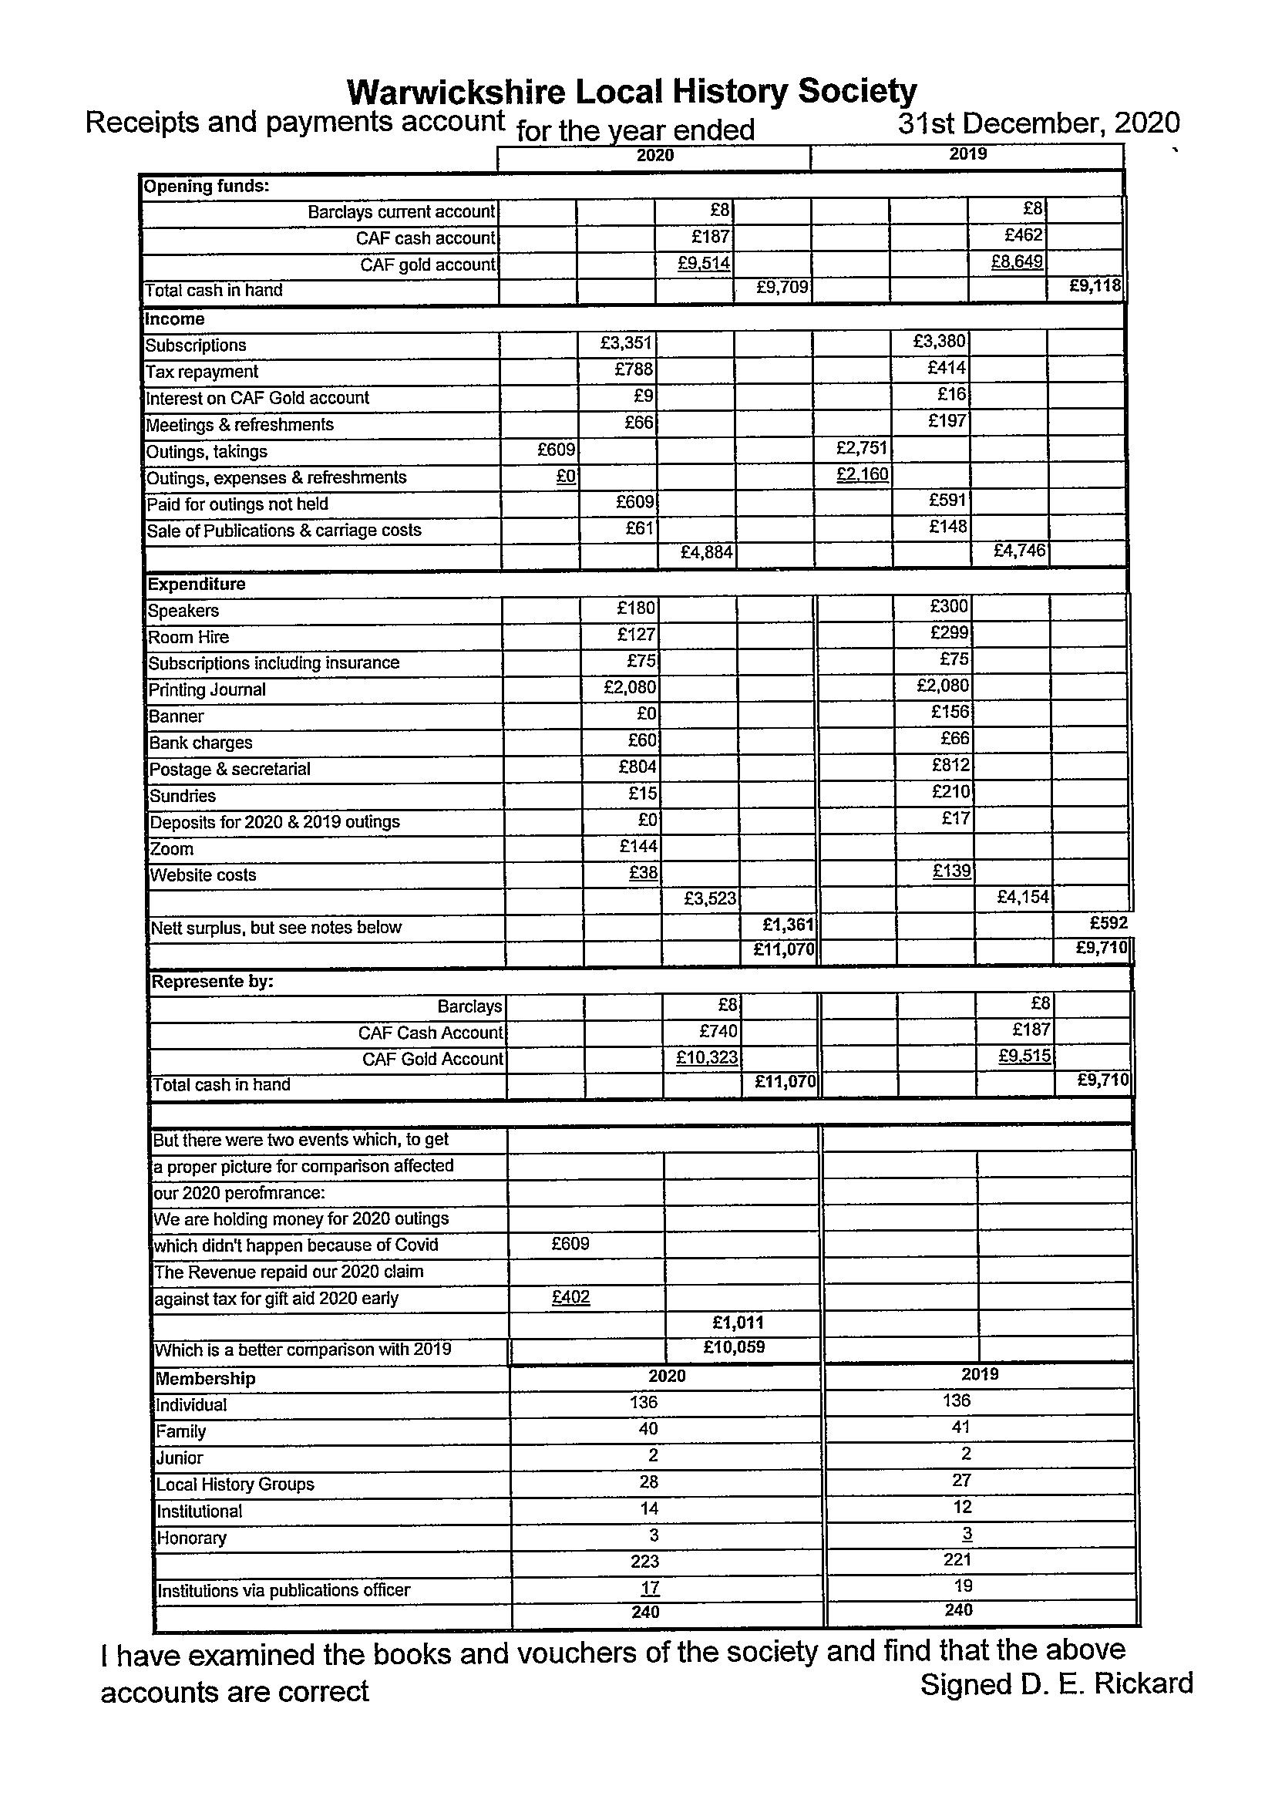
Our total funds do not reflect the true situation £11,070
For we are still holding money for 2020 outings £609
Also, the Revenue repaid 2 lots of gift aid tax £402 £ 1,011
Thus, the total funds stand at £10,059

